Relationship Between Pixels

Program1:

img = imread('watch.jpg');
img = rgb2gray(img);
img = imresize(img,[20 20]);

x = 8;
y = 8;

P = img(x,y);

disp('Center Pixel Value:');
disp(P);

N4 = [img(x-1,y), img(x+1,y), img(x,y-1), img(x,y+1)];

disp('4-Neighborhood Pixels:');
disp(N4);

sumN4 = sum(double(N4));

disp('Sum of N4 Pixels:');
disp(sumN4);

N8 = [img(x-1,y-1) img(x-1,y) img(x-1,y+1) ...
img(x,y-1) img(x,y+1) ...
img(x+1,y-1) img(x+1,y) img(x+1,y+1)];

disp('8-Neighborhood Pixels:');
disp(N8);

Output:

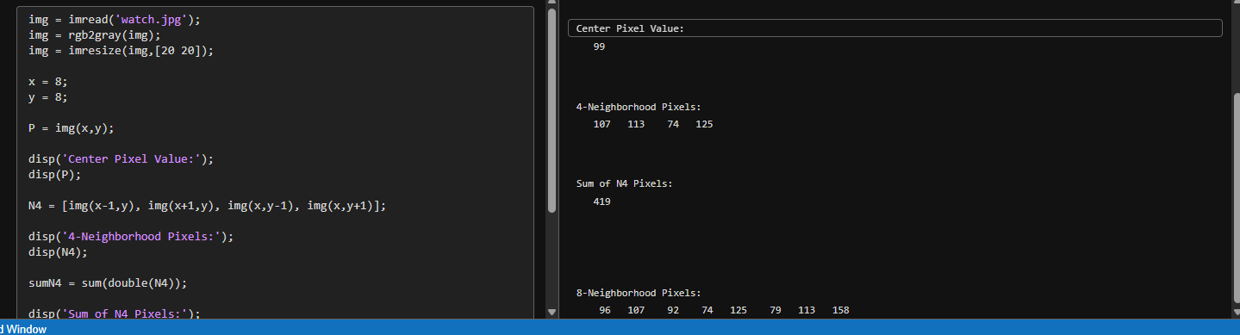

Transformation Of An Image

Program2:

[filename, pathname] = uigetfile({'*.jpg;*.png;*.bmp'}, ...
'Select an Image');

img = imread(fullfile(pathname, filename));

figure;

% Original Image
subplot(2,3,1);
imshow(img);
title('Original');

% Translation
translated = imtranslate(img,[70 30]);
subplot(2,3,2);
imshow(translated);
title('Translated');

% Rotation
rotated = imrotate(img,30);
subplot(2,3,3);
imshow(rotated);
title('Rotated');

% Cropping
cropped = imcrop(img,[100 10 200 205]);
subplot(2,3,4);
imshow(cropped);
title('Cropped');

Output:

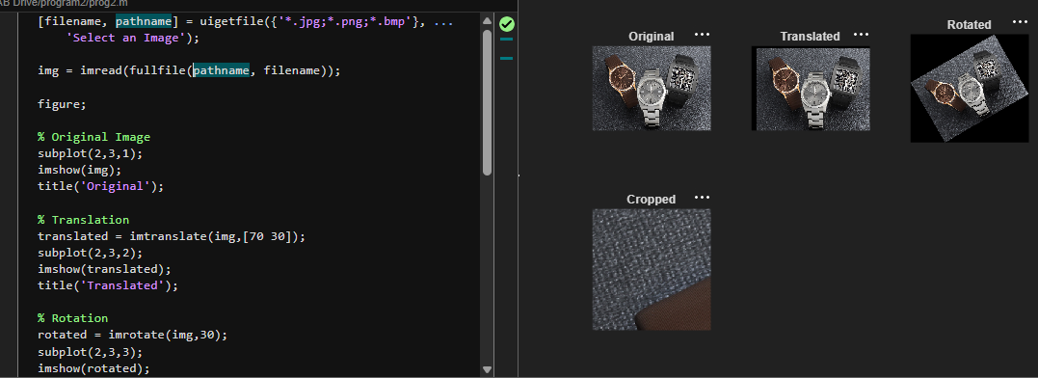

Histogram Equalization

Program3:

clc;
clear;
close all;

% Read image
img = imread('cameraman.tif');

%Histogram equalization
eq_img = histeq(img);

% Display images
figure;

subplot(2,2,1);
imshow(img);
title('Original Image');

subplot(2,2,2);
imhist(img);
title('Original Histogram');

subplot(2,2,3);
imshow(eq_img);
title('Equalized Image');

subplot(2,2,4);
imhist(eq_img);
title('Equalized Histogram');

Output:

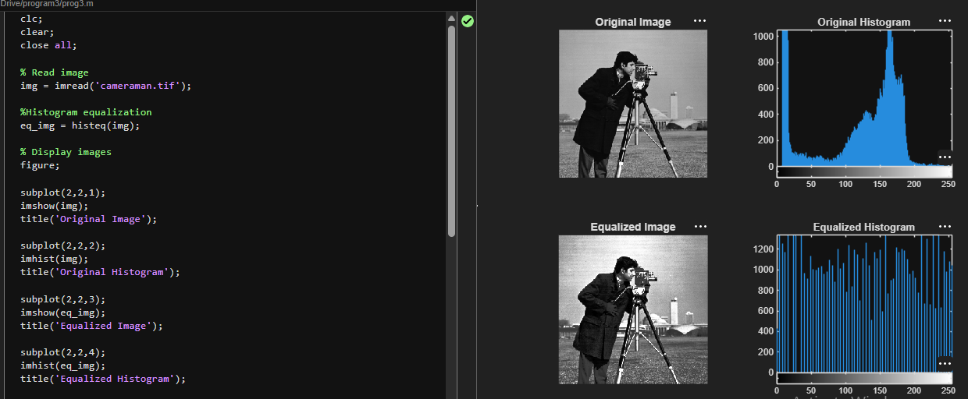

Image Enhancement Technique

Program4:
[filename, pathname] = uigetfile({'*.jpg;*.png;*.bmp'}, 'Select a Grayscale Image');
img = imread(fullfile(pathname, filename));

if size(img,3) == 3
img = rgb2gray(img);
end
figure, imshow(img), title('Original Image');
smooth = imgaussfilt(img, 1);
figure, imshow(smooth), title('Smoothed (Gaussian Blur)');
h_sharp = [0 -1 0; -1 5 -1; 0 -1 0];
sharpen = imfilter(img, h_sharp);
figure, imshow(sharpen), title('Sharpened Image');
gamma = 1.5; gamma_corrected = imadjust(img, [], [], gamma); figure, imshow(gamma_corrected), title('Gamma Corrected (γ=1.5)');

Output:

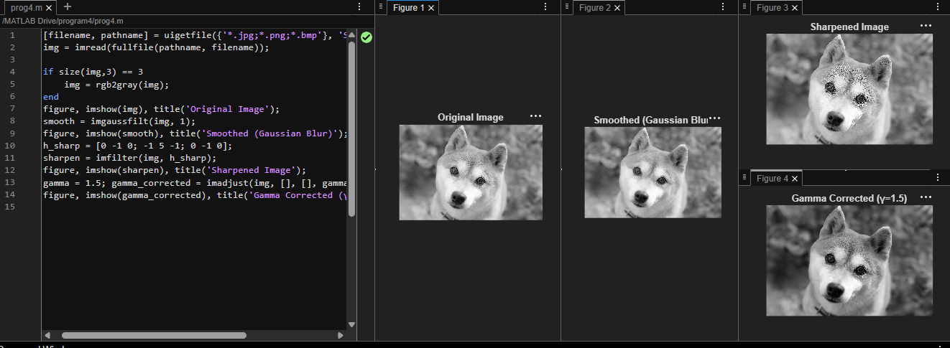

IMAGE RESTORATION

Program5:

clc;
clear;
close all;

[file,path] = uigetfile({'*.jpg;*.png;*.bmp'},'Select Image');
img = imread(fullfile(path,file));

gray = im2gray(img);
deblur = imbilatfilt(gray);
denoise = medfilt2(deblur,[3 3]);
result = regionfill(denoise, denoise < 5);

figure;
subplot(2,2,1), imshow(gray), title('Original');
subplot(2,2,2), imshow(deblur), title('Deblurred');
subplot(2,2,3), imshow(denoise), title('Denoised');
subplot(2,2,4), imshow(result), title('Restored');

Output:

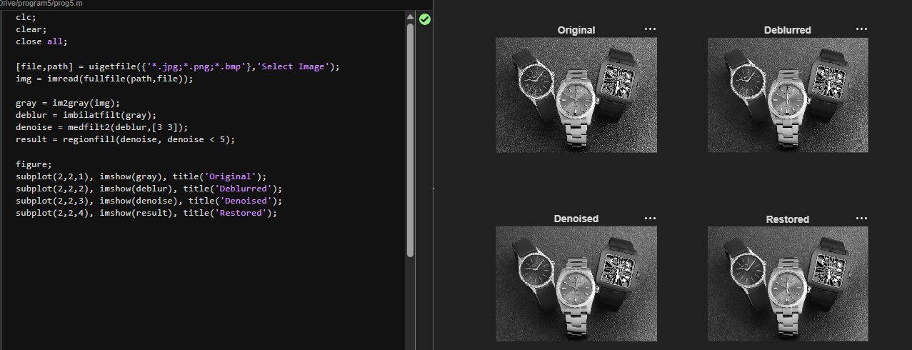

IMAGE FILTERING

Program6:

[fn,pn] = uigetfile({'*.jpg;*.png;*.bmp'}, 'Select an image');
img = imread(fullfile(pn,fn));

hsvImg = rgb2hsv(img);
hue = hsvImg(:,:,1);

mask = (hue < 0.05 | hue > 0.95);
segmented = img;
segmented(repmat(~mask, [1 1 3])) = 0;

gray = rgb2gray(img);
gray = cat(3,gray,gray,gray);
colorPop = gray;
colorPop(repmat(mask,[1 1 3])) = img(repmat(mask,[1 1 3]));

figure;
subplot(1,3,1); imshow(img); title('Original');
subplot(1,3,2); imshow(segmented); title('Color Segmentation (Red)');
subplot(1,3,3); imshow(colorPop); title('Color Pop Effect (Red)');

Output:

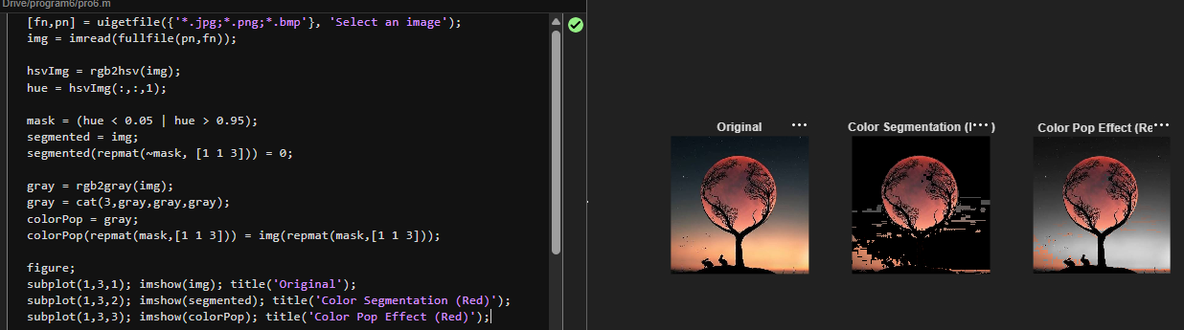

EDGE DETECTION USING OPERATORS

Program7:

[fn,pn] = uigetfile({'*.jpg;*.png;*.bmp'}, 'Select an image');
img = imread(fullfile(pn,fn));
gray = rgb2gray(img);
edges_sobel = edge(gray, 'sobel');
edges_prewitt = edge(gray, 'prewitt');
edges_roberts = edge(gray, 'roberts');
subplot(2,2,1), imshow(gray), title('Original Grayscale');
subplot(2,2,2), imshow(edges_sobel), title('Sobel Edges');
subplot(2,2,3), imshow(edges_prewitt), title('Prewitt Edges');
subplot(2,2,4), imshow(edges_roberts), title('Roberts Edges');

Output:

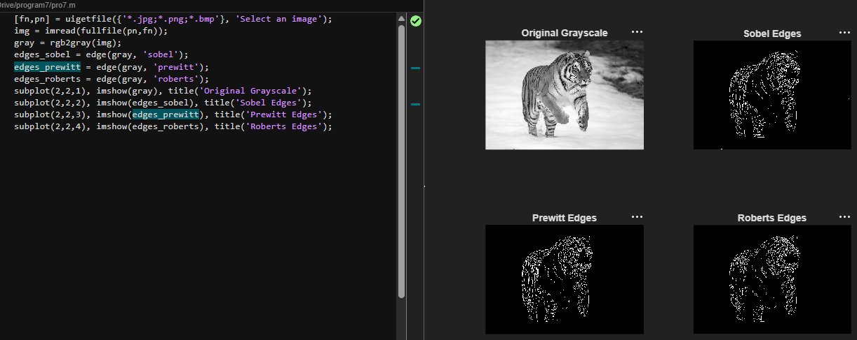

IMAGE COMPRESSION

Program8:

[f,p] = uigetfile({'*.jpg;*.png;*.bmp'});
I = rgb2gray(imread(fullfile(p,f)));
D = dct2(double(I));
D(abs(D)<50) = 0;
C = idct2(D);
figure, imshow(I), title('Original Image');
figure, imshow(uint8(C)), title('Compressed Image');
orig_kb = numel(I)*8/1024;
orig_mb = orig_kb/1024;

comp_kb = nnz(D)*8/1024;
comp_mb = comp_kb/1024;

CR = orig_kb/comp_kb;

fprintf('Original Size: %.2f KB (%.4f MB)\n', orig_kb, orig_mb);
fprintf('Compressed Size: %.2f KB (%.4f MB)\n', comp_kb, comp_mb);
fprintf('Compression Ratio = %.2f\n', CR);

Output:

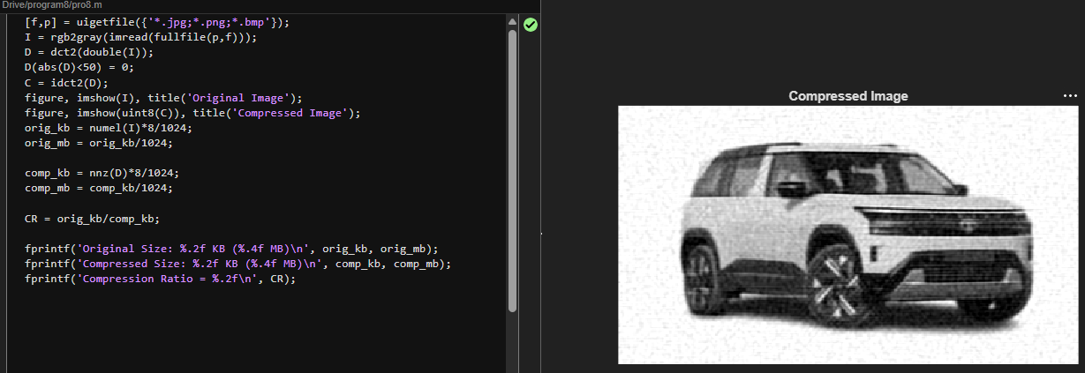

BOUNDARY EXTRACTION USING MORPHOLOGY

Program9:

[fn,pn] = uigetfile({'*.jpg;*.png;*.bmp'}, 'Select an image');
img = imread(fullfile(pn,fn));
gray = rgb2gray(img);

edges_sobel = edge(gray, 'sobel');

edges_prewitt = edge(gray, 'prewitt');

edges_roberts = edge(gray, 'roberts');

subplot(2,2,1), imshow(gray), title('Original Grayscale');
subplot(2,2,2), imshow(edges_sobel), title('Sobel Edges');
subplot(2,2,3), imshow(edges_prewitt), title('Prewitt Edges');
subplot(2,2,4), imshow(edges_roberts), title('Roberts Edges');

Output:

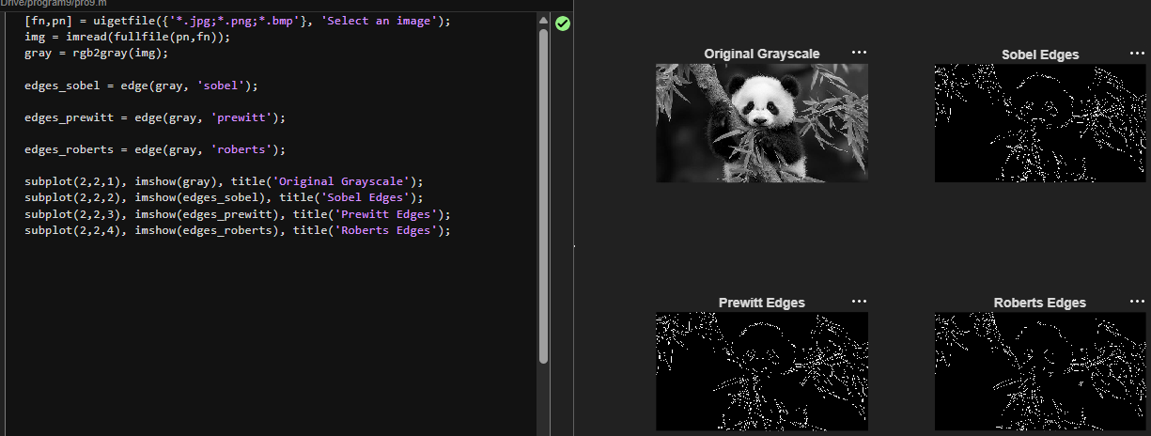

IMAGE SEGMENTATION

Program10:

clc;
clear all;
close all;

img = imread('catty.jpg');

if size(img, 3) == 3
gray_img = rgb2gray(img);
else
gray_img = img;
end

level = graythresh(gray_img);
segmented_img = imbinarize(gray_img, level);

subplot(1,2,1);
imshow(gray_img);
title('Original Grayscale Image');

subplot(1,2,2);
imshow(segmented_img);
title(['Segmented Image (Threshold = ', num2str(round(level*255)), ')']);

Output:

